sgz1-t3-51282-fdp-haas-prd

May 12th 2026 to May 19th 2026

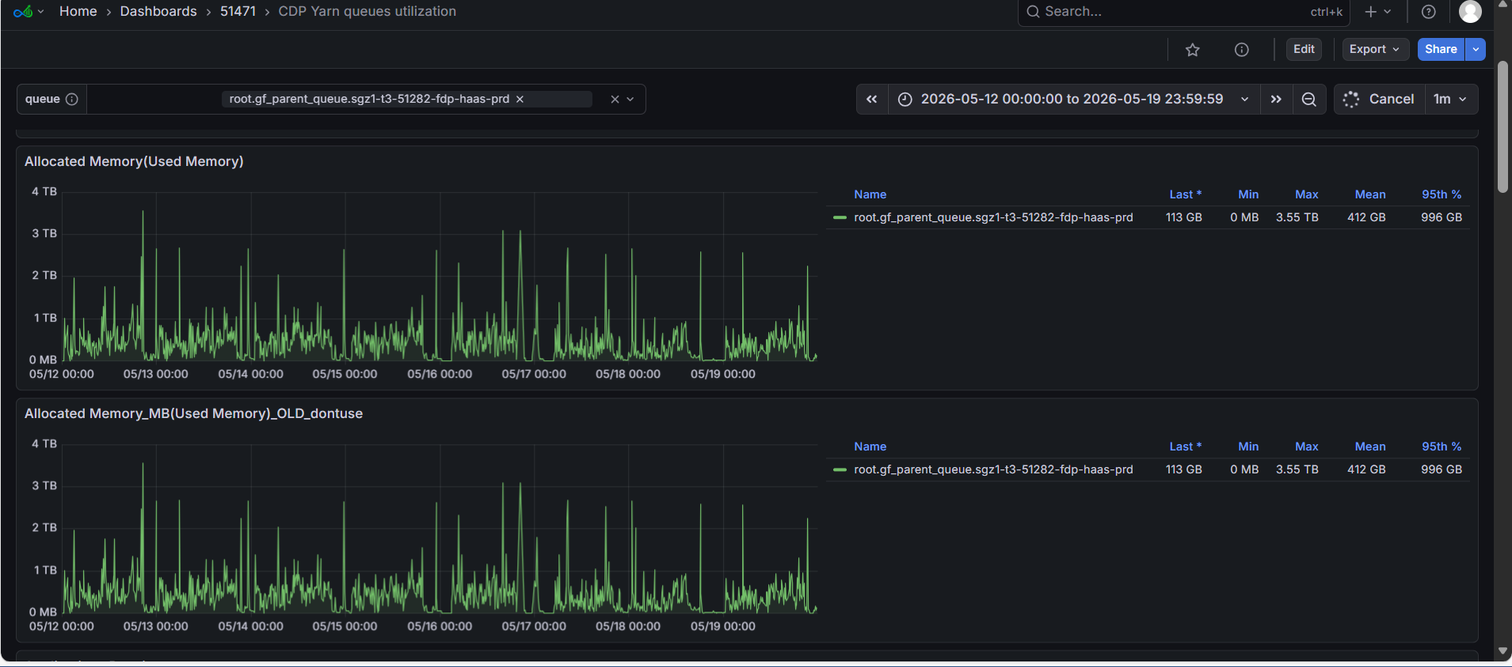

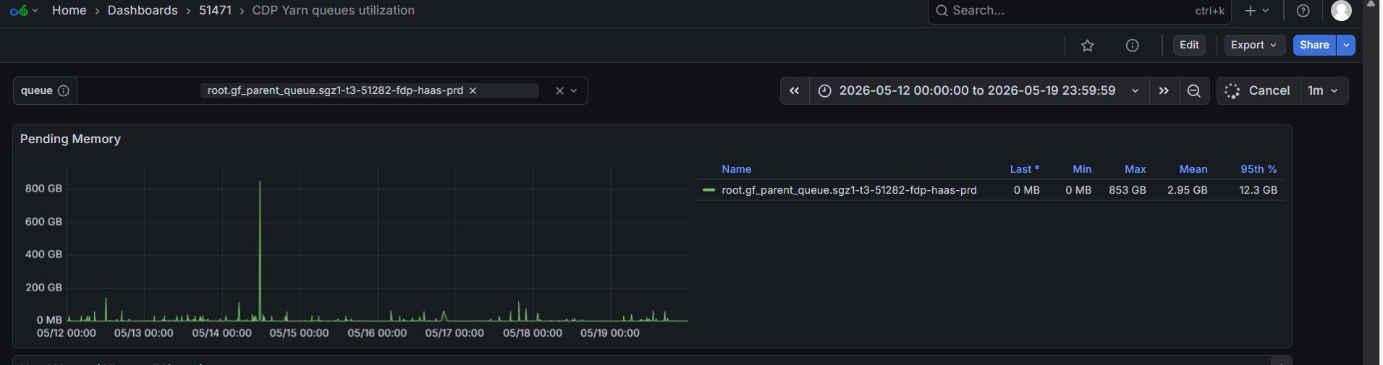

Last 1 hour

